Bird Strike Analysis

Table of Contents

SL No | Topic | Pg No
1. | Problem Statement | 2
2. | Introduction | 3
3. | About Data & Data Collection | 4
4. | Data Cleaning & Data Analysis | 5-10
5. | Insights From Code | 11
6. | Data Visualization | 12-15
7. | Insights From Data Visualization | 16
8. | Conclusion | 17

Problem Statement

Transport and communication are in the crucial domain in the field of analytics.
Environmental impacts and safety are, nowadays, two major concerns of the scientific
community with respect to transport scenarios and to the ever-growing urban areas.
These issues gain more importance due to the increasing amount of vehicles and
people. Seeking new solutions is reaching a point where available technologies and
artificial intelligence, especially MAS, are being recognized as ways to cope with and
tackle these kinds of problems in a distributed and more appropriate way.

A bird strike is strictly defined as a collision between a bird and an aircraft which is in
flight or on a take-off or landing roll. The term is often expanded to cover other wildlife
strikes - with bats or ground animals. Bird Strike is common and can be a significant
threat to aircraft safety. For smaller aircraft, significant damage may be caused to the
aircraft structure and all aircraft, especially jet-engine ones, are vulnerable to the loss
of thrust which can follow the ingestion of birds into engine air intakes. This has
resulted in several fatal accidents.

Bird strikes may occur during any phase of flight, but are most likely during the
take-off, initial climb, approach and landing phases due to the greater numbers of birds
in flight at lower levels. To have a closer look the following document visually depicts
the data collected on Bird Strikes by FAA between 2000-2011.

Introduction

- A bird strike refers to a collision between a bird and an aircraft, typically occurring during takeoff, landing, or low-altitude flight. This phenomenon poses a significant safety hazard to aviation as it can lead to severe damage to aircraft structures, engines, or flight control systems. Although modern aircraft are designed to withstand bird strikes to some extent, they still represent a considerable threat, especially when larger birds or flocks are involved.

- Bird strikes are most common at altitudes below 3,000 feet, close to airports where aircraft are ascending or descending. They can cause engine failure, windshield damage, and in rare cases, even result in catastrophic accidents. One notable incident is the Miracle on the Hudson in 2009, where a bird strike led to the engine failure of a commercial airliner, forcing the pilot to perform an emergency landing on the Hudson River, saving all passengers onboard.

- Aviation authorities, such as the Federal Aviation Administration (FAA), and airports take proactive measures to reduce the likelihood of bird strikes. These include habitat management around airports, bird-scaring techniques, radar systems to detect bird activity, and design improvements to aircraft to mitigate the effects of bird strikes. Despite these efforts, bird strikes remain a persistent challenge in aviation safety.

- While most bird strikes are not fatal, they can result in costly repairs and delays. Continuous research and technological advancements are being made to improve bird strike prevention and aircraft resilience.

About Data and Data Collection

- Data obtained from unified mentor
- Shape of the data: (25558,26).
- Column Names
- Record ID: Unique for every Record
- Aircraft: Type: Airplane Only.
- Airport: Name: Name of the airport present in U.S.A.
- Altitude bin: Strike is categorized under >1000ft and <1000ft.
- Aircraft: Make/Model: Model of the Aircraft.
- Wildlife: Number struck: Number of wildlife that struck the aircraft.
- Wildlife: Number Struck Actual
- Effect: Impact to flight : Impact it caused to effect.
- Flight Date : Date and time recorded.
- Effect: Indicated Damage
- Aircraft: Number of engines?
- Aircraft: Airline/Operator
- Origin State
- When: Phase of flight
- Conditions: Precipitation
- Remains of wildlife collected: Yes/No.
- Remains of wildlife sent to Smithsonian
- Remarks
- Wildlife: Size
- Conditions: Sky
- Wildlife: Species: Name of the species.
- Pilot warned of birds or wildlife: Yes/No.
- Cost: Total $: Cost incurred in dollars
- Feet above ground: Height above ground.
- Number of people injured
- Is Aircraft Large: Yes/No.
Data Cleaning & Data Analysis
- Data cleaning explained with code and result as below

import pandas as pd
import numpy as np
import matplotlib.pyplot as plt
import seaborn as sns

# Reading the shape of data before cleaning
df = pd.read_excel('data/Bird Strikes data.xlsx')
# print(df.shape)
# Result: (25558, 26)

# To check the number of records and the data type of the columns
# print(df.info())

# Checking the number of duplicate records
duplicate_records = df.duplicated().sum()
# print(duplicate_records)
# Result: 0

# Checking the missing values in records
missing_values = df.isnull().sum()
# print(missing_values)

# Handling missing values
# Replace None with other value because pandas as read none precipication as NaN
df['Conditions: Precipitation'] = df['Conditions: Precipitation'].fillna('No precipitation')

# Replace None with other value in Effect: Impact to flight column
df['Effect: Impact to flight'] = df['Effect: Impact to flight'].fillna("No imapct")

# Replacing N/A(Not avaiable) in origin state to unknown
df['Origin State'] = df['Origin State'].fillna("unknown")

# Drpping Remarks column
df.drop('Remarks', axis=1, inplace=True)

# Replace missing values in Aircraft: Number of engines? to unknown due to confidentiality.
df['Aircraft: Number of engines?'] = df['Aircraft: Number of engines?'].fillna("Unknown")

# Dropping the rest of the records with missing values as it is only 129 records
df.dropna(axis=0, how = 'any', inplace= True)

# Checking missing values after handling it
missing_valuess = df.isnull().sum()
# print(missing_valuess)
# Result: 0

# Data type correction
df['Record ID'] = df['Record ID'].astype(int)
df['Altitude bin'] = df['Altitude bin'].astype('category')
df['Wildlife: Number struck'] = df['Wildlife: Number struck'].astype('category')
df['Is Aircraft Large?'] = df['Is Aircraft Large?'].astype(bool)
# To convert to int we must remove commas which is str operation so first convert datatype to str
df['Feet above ground'] = df['Feet above ground'].astype(str)
df['Feet above ground'] = df['Feet above ground'].str.replace(',', '')
df['Feet above ground'] = df['Feet above ground'].astype(float)
# To convert to int we must remove commas which is str operation so first convert datatype to str
df['Cost: Total $'] = df['Cost: Total $'].astype(str)
df['Cost: Total $'] = df['Cost: Total $'].str.replace(',', '')
df['Cost: Total $'] = df['Cost: Total $'].astype(float)

# Records correction
df['Airport: Name'] = df['Airport: Name'].str.title()
df['Aircraft: Airline/Operator'] = df['Aircraft: Airline/Operator'].str.title()

# Creating Columns
# Creating 3 new columns out of FlightDate column
df['FlightDate'] = pd.to_datetime(df['FlightDate'])
df['Year'] = df['FlightDate'].dt.year
df['Month'] = df['FlightDate'].dt.month
df['Day'] = df['FlightDate'].dt.day
# Creating season column for efficient data analysis
season_mapping = {
1: 'Winter',
2: 'Winter',
3: 'Spring',
4: 'Spring',
5: 'Spring',
6: 'Summer',
7: 'Summer',
8: 'Summer',
9: 'Autumn',
10: 'Autumn',
11: 'Autumn',
12: 'Winter'
}
df['Season'] = df['Month'].map(season_mapping)
# Creating regions column
# Dictionary to map states to regions
state_region_dict = {
'Connecticut': 'Northeast',
'Maine': 'Northeast',
'Massachusetts': 'Northeast',
'New Hampshire': 'Northeast',
'Rhode Island': 'Northeast',
'Vermont': 'Northeast',
'New Jersey': 'Northeast',
'New York': 'Northeast',
'Pennsylvania': 'Northeast',
'Florida': 'Southeast',
'Georgia': 'Southeast',
'South Carolina': 'Southeast',
'North Carolina': 'Southeast',
'Virginia': 'Southeast',
'West Virginia': 'Southeast',
'Maryland': 'Southeast',
'Delaware': 'Southeast',
'Kentucky': 'Southeast',
'Tennessee': 'Southeast',
'Alabama': 'Southeast',
'Mississippi': 'Southeast',
'Arkansas': 'Southeast',
'Louisiana': 'Southeast',
'District of Columbia': 'Southeast',
'Illinois': 'Midwest',
'Indiana': 'Midwest',
'Michigan': 'Midwest',
'Ohio': 'Midwest',
'Wisconsin': 'Midwest',
'Iowa': 'Midwest',
'Kansas': 'Midwest',
'Minnesota': 'Midwest',
'Missouri': 'Midwest',
'Nebraska': 'Midwest',
'North Dakota': 'Midwest',
'South Dakota': 'Midwest',
'Texas': 'Southwest',
'Oklahoma': 'Southwest',
'New Mexico': 'Southwest',
'Arizona': 'Southwest',
'Alaska': 'West',
'California': 'West',
'Hawaii': 'West',
'Oregon': 'West',
'Washington': 'West',
'DC' : 'West',
'Colorado': 'West',
'Idaho': 'West',
'Montana': 'West',
'Nevada': 'West',
'Utah': 'West',
'Wyoming': 'West',
'Virgin Islands': 'Virgin Islands',
'Puerto Rico': 'Puerto Rico',
'Prince Edward Island' : 'Canada',
'Quebec' : 'Canada',
'Ontario' : 'Canada',
'British Columbia' : 'Canada',
'Saskatchewan' : 'Canada',
'Alberta' : 'Canada',
'Newfoundland and Labrador' : 'Canada',
'unknown' : 'Canada'
}
df['Region'] = df['Origin State'].map(state_region_dict)

# Visualizing outliers in 'Feet above ground'
sns.boxplot(x=df['Feet above ground'])
# plt.show()

Q1 = df['Feet above ground'].quantile(0.25)
Q3 = df['Feet above ground'].quantile(0.75)
IQR = Q3 - Q1

lower_bound = Q1 - 1.5 * IQR
upper_bound = Q3 + 1.5 * IQR

outliers = df[(df['Feet above ground'] < lower_bound) | (df['Feet above ground'] > upper_bound)]
# print(outliers[['Feet above ground']].count())
# Result 3803 records

# Visualizing outliers in 'Cost: Total $'
sns.boxplot(x=df['Cost: Total $'])
# plt.show()

Q1 = df['Cost: Total $'].quantile(0.25)
Q3 = df['Cost: Total $'].quantile(0.75)
IQR = Q3 - Q1

lower_bound = Q1 - 1.5 * IQR
upper_bound = Q3 + 1.5 * IQR

outlierss = df[(df['Cost: Total $'] < lower_bound) | (df['Cost: Total $'] > upper_bound)]
# print(outlierss[['Cost: Total $']].count())
# Result: 1214 rows

# Outliers found reasonable so kept intact

# print(df.describe()) # Insights generated

# df.to_excel("Bird_Strike_Data_Cleaned.xlsx", index = False)

Insights from Code
- The dataset consists of 25,429 records.
- The dates range from January 2, 2000, to December 31, 2011.
- Max wildlife strike is 942.
- Mean number of wildlife strike is 2.70.
- Cost occurrence range from: $0 - $ 12,397,750.
- Mean of cost occurrence: $5,566.
- The average height at which these incidents occur is about 799 feet above ground. This suggests that wildlife strikes typically happen during takeoff or landing phases of flight when aircraft are lower in altitude.
- There were no reported injuries in the majority of incidents, as indicated by the mean of 0.0008 for the number of people injured. The maximum number of people injured in a single incident is 6.
- Of the total data only 225 belongs to animals that aren’t birds which is less that1% so we consider whole data as bird strike data.
- There are total 345 unique species present and out of that only 20 species are not birds
- And their records constitute less than 1 % hence it is included as bird strike.
- Season and geographical regions of America were mapped to existing data.

Data Visualization
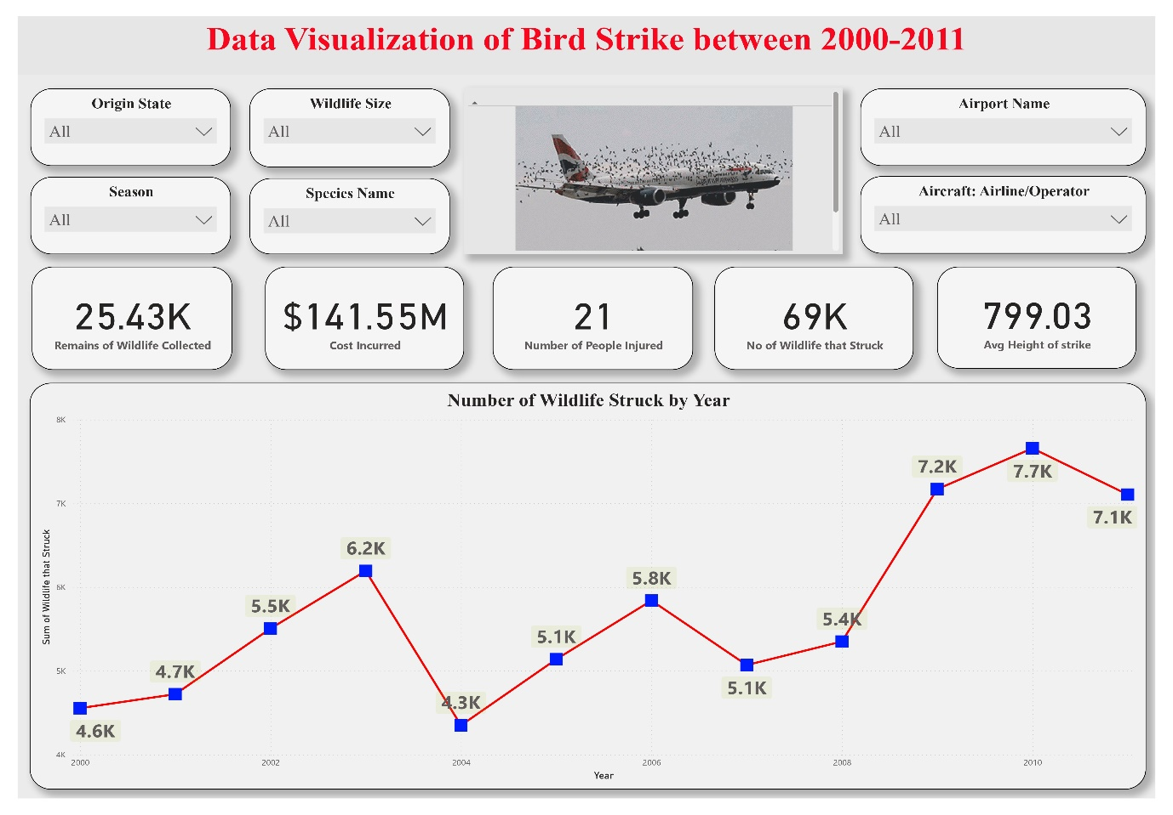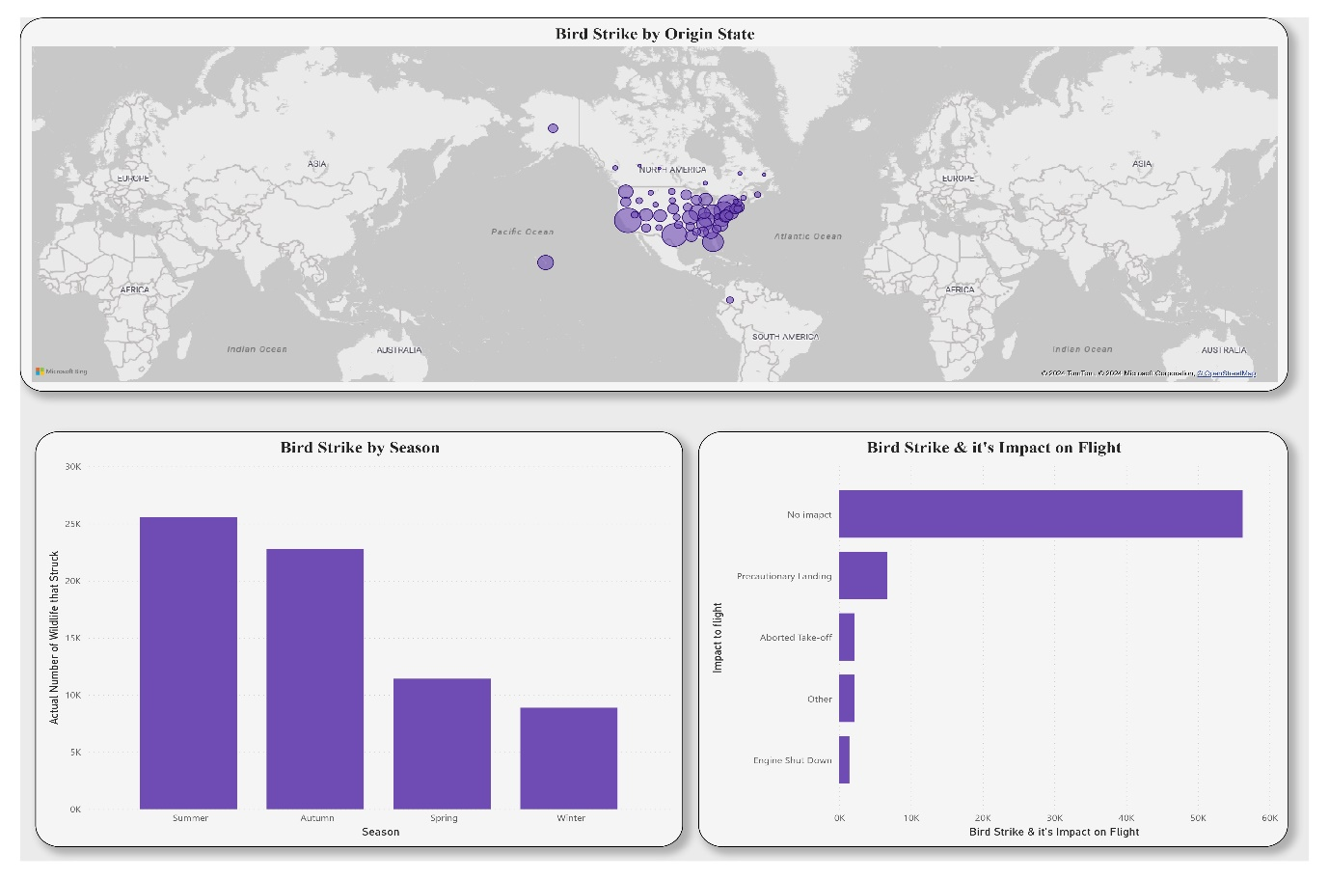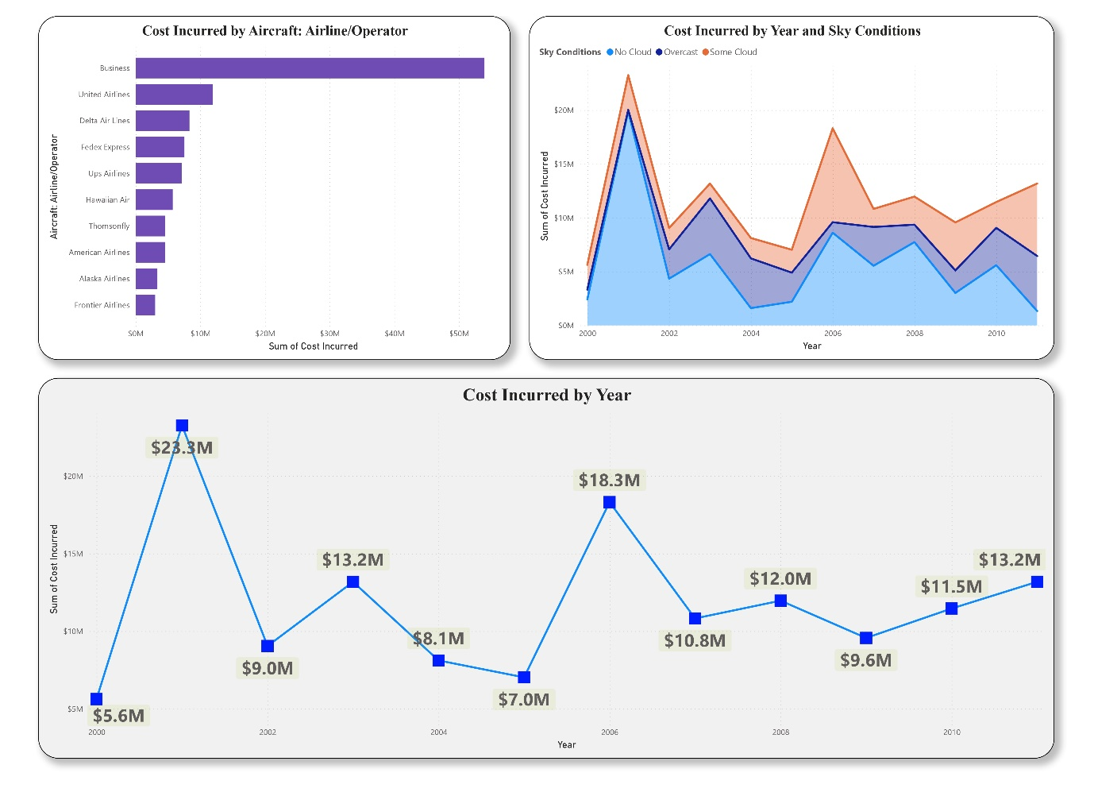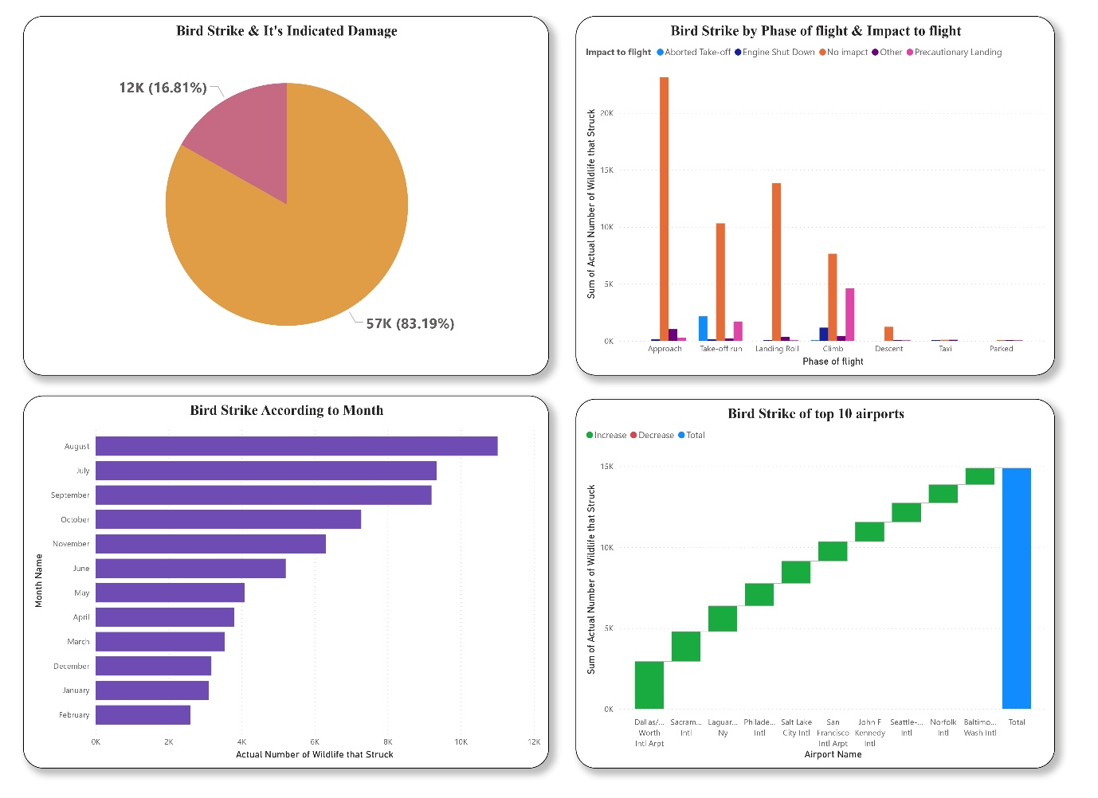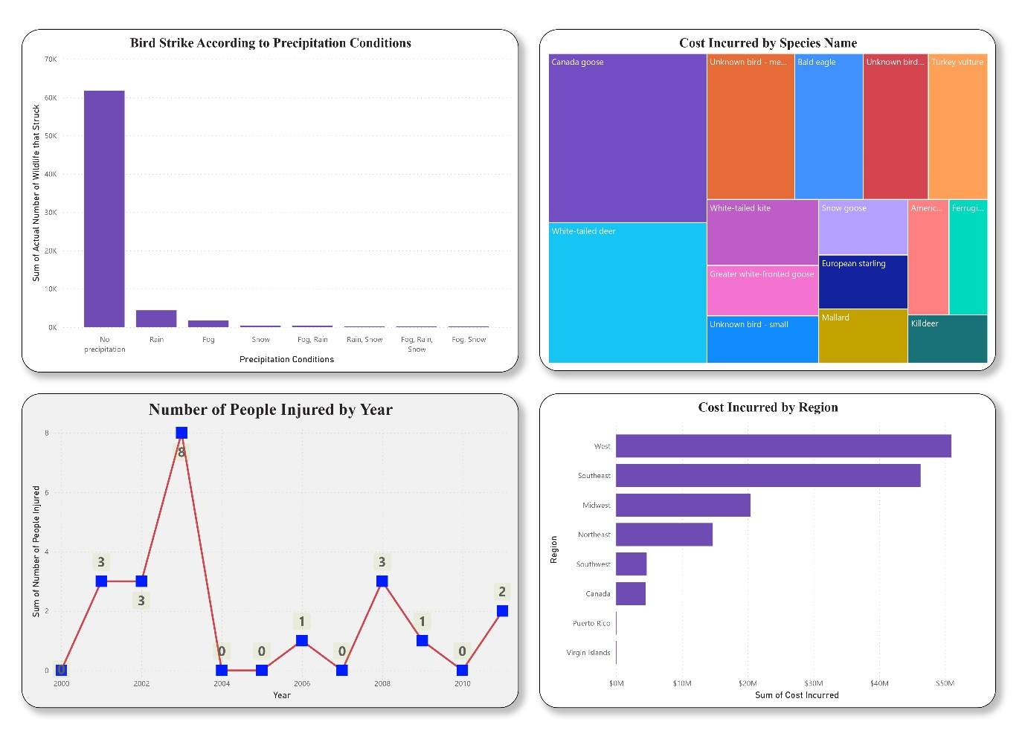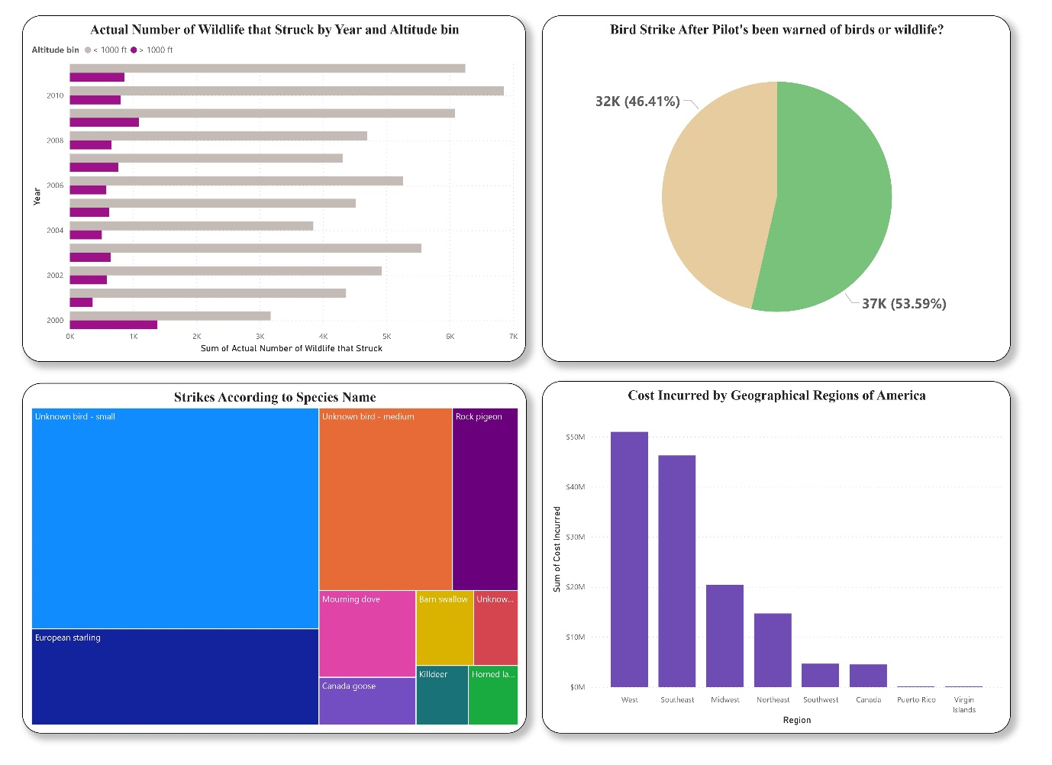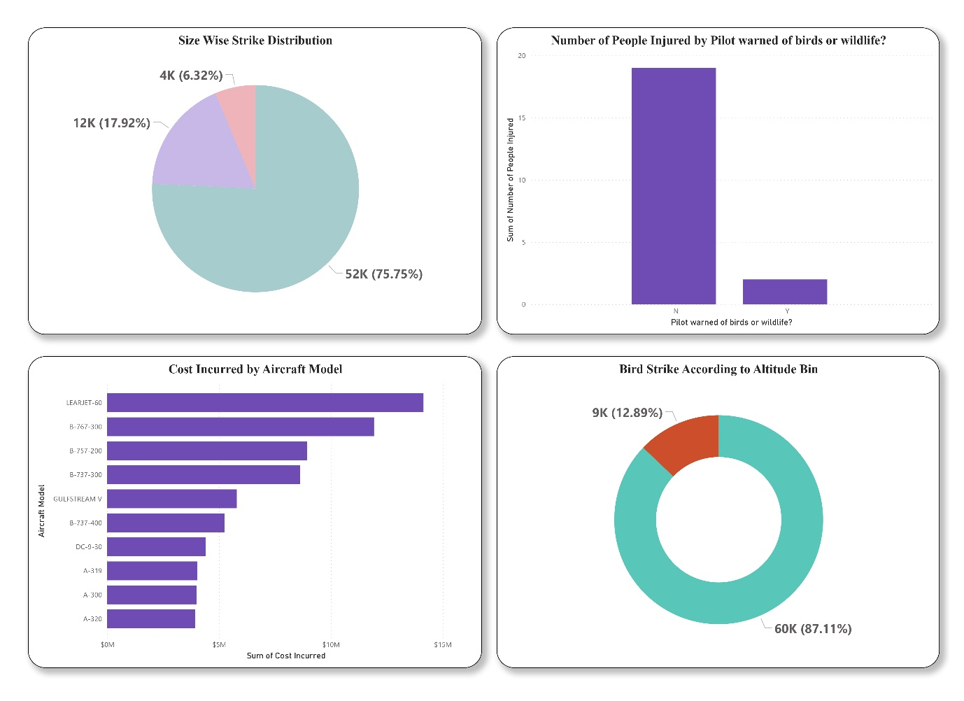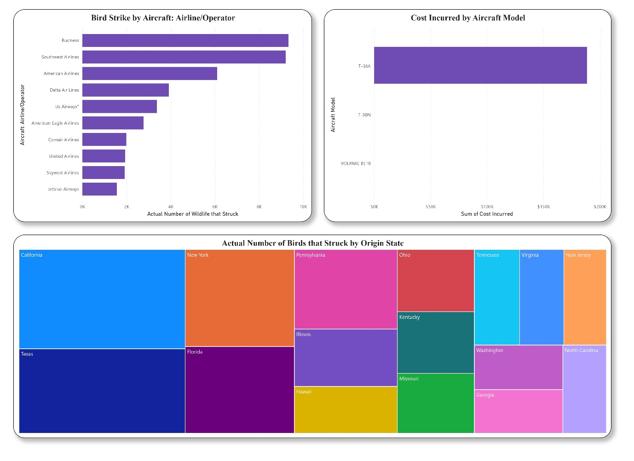
Insights from Visualization in Power BI

- Remains of wildlife collected: 25.43k.
- Total cost incurred due to strikes: $141.5M.
- Number of injured: 21.
- Number of wildlife that struck: 69k.
- Avg height of strike: 800m.
- 2010 is recorded as the year with highest strike.
- California is the state with highest strike.
- Summer season records the highest strikes followed by autumn, spring and winter.
- Most of the strikes doesn’t have much impact on the plane but it did cause for precautionary landing & aborted take – off.
- 2001 is the year where most money was spent to repair the damages.
- Business aircraft was the one to bear the most cost and it is followed by United Airlines.
- August month Recorded the highest bird strike followed by July, September, October, November. Which is basically summer seasons in america
- Dalls/Fort Worth Intl Airport is the airport which has recorded the highest strike and it is in Texas.
- Most bird strike happened during no precipitation condition in sky followed by rain fog, snow.
- 2003 was the year when most people were injured that stands to 8.
- Western states of America that is California, Washington, Arizona, Nevada, Alaska etc was recorded with highest bird strike among other regions of America.
- Cannada Goose and white tailed deer are the animals which caused significant damage to the aircraft.
- Most of the bird strike are recorded below the altitude level of 1000ft.
- Small unkown bird and European starling are the species which recorded highest strikes for an aircraft.
- If we distribute the wildlife among small medium and large we get to see that most strikes are caused by small wildlife.
- LEARJET- 60 is the aircraft which has beared more money for a bird stike.
- Top 5 states with most bird strike are California, Texas, NY, Florida, Pennsylvania.
Conclusion

- Flight Scheduling Adjustments: Avoid flights during peak bird activity times like dawn, dusk, and migration seasons.
- Airport Habitat Management: Remove water sources and food around airports to keep birds away.
- Wildlife Detection Systems: Use radar to track bird activity near airports and warn pilots in real-time.
- Species-Specific Deterrents: Employ strategies like sound cannons or trained animals to scare off birds.
- Aircraft Design Enhancements: Strengthen windshields and engines to withstand bird impacts.
- Altitude Management: Fly at safer altitudes during bird-heavy periods.
- Better Lighting Systems: Install lighting that deters birds from approaching aircraft and runways.
- Bird Monitoring and Forecasting: Use historical data to predict bird movements and adjust flight paths or issue warnings when large flocks are expected.
- Drone Patrols: Deploy drones around airports to scare birds away before flights.
- Bird Deterrent Technology: Install laser systems or reflective surfaces that create visual barriers to keep birds from entering runways.
- Regular Aircraft Inspections: Increase frequency of inspections after flights, especially during migration seasons, to catch any bird-related damage early.
- Pilot Training: Train pilots on bird strike avoidance techniques, such as quick altitude changes or using specific angles of approach and departure.

THANK YOU

